**ABSTRACT**

More than 40 percent of the population in the world chooses agriculture as the primary occupation.Advancement of agricultural tools is the basic trend of agricultural improvement. Today’s era is marching towards the rapid growth of all sectors including the agriculture sector to meet the future food demands,the farmers have to implement the new technologies which will not affect the soil texture but will increase the overall crop production. The project aim is to design,develop and the fabrication of the robot which can dig the soil ,sow seeds,level the land after sowing and spray fertilizers,this whole system works on the battery charged with help of solar panel. This robotic vehicle is controlled through bluetooth interfacing on android application minimizes the labour of farmers increasing the speed and accuracy of the work.

**CHAPTER-1**

**INTRODUCTION**

* 1. **Introduction to the project:**

The main motive for developing agricultural automation technology is decreasing labor force and increasing the processes of digging and seed sowing of crops and covering the land so that human efforts will get reduce up to 90 percent. Especially when the duties,that needs to be performed,are potentially harmful for the safety or the health of the workers or when more conservative issues the applications of instrumental robotics cover further domains, as the opportunity of replacing human operators provides effective solutions with return on investment.

* 1. **LITERATURE SURVEY**

In agriculture the use of robots enhances the productivity and reduces the human effort and cost. The automation of various agricultural activities by robots are envisioned. Robots have been successfully used in several industrial applications like material handling,material transfer,processing,inspection & quality control. The idea of mechanization of agriculture was most obvious in recent years and there are many success stories of robotic agriculture.The reasons for usage of robots in agriculture are to improve food quality & productivity. One more important reason for robotic agriculture is the unavailability of skilled man power in agricultural sector and it affects the growth of developing countries. Robots have successfully been used in agricultural activities like seeding,harvesting,weed control,grove supervision,chemical applications,etc. In india about 70% of population is dependent on agriculture. Therefore,if the farmers are empowered with support of robots, the agricultural output of the nation can improve radically.

The primary agricultural activity done by the support of robots today is at the harvesting stage. Possible emerging applications are robots or drones for weed control. Developed agriculture needs to find new ways to improve efficiency. One approach is to utilize available information technologies in the form of more intellegent machines to reduce and target energy inputs in more effective ways than in the past.agribot is a robot designed for a agricultural purposes. As one of the trends of development on automation and intelligence of agricultural machinery in the 21st century, all kinds of agricultural robots have been researched and developed to implement a number of agricultural production activities in many countries. The advent of autonomous system architectures gives us the opportunity to develop a complete new range of agricultural equipment based on small smart machines that can do the right thing, in the right place , at the right time, in the right way. Furthermore, such automation can improve the farmer’s comfort, as the tracking task is performed by the vehicle itself.

###### CHAPTER -2

###### INTRODUCTION ABOUT EMBEDDED SYSTEMS

**2.1 Introduction:**

During additional complex frameworks an n application that allows the implanted framework used a particular cause in specific work which takes the operation of the installed framework. The ability of programs to implement an identical fixed framework is regularly used in a spread of different applications. Now and again, a microchip could likewise be planned how that application programming for a particular reason for existing is frequently added to the fundamental programming during a subsequent cycle, after which it's difficult to frame.

The least complex gadgets contain one microchip (regularly "chip"), which would itself able to be bundled with different chips during the mixture framework for Application for microcircuit (ASIC). It comes from locator would itself able to be bundled different chips during an activity sensor, operating measure, define the progression of activator to the motor.

**2.2 Block diagram of an embedded system:**

**Software**

**Hardware**

* **ALP**
* **C**
* **VB**

**Etc.,**

* **Processor**
* **Peripherals**
* **memory**

**Embedded**

**System**

Fig.2.2: Block diagram of specified embedded system

2.3 Applications of embedded systems:

* Architecture and establishment
* Public services
* Telecom services
* Commercial usage
* Medical
* Testing and surveillance

2.4 Micro Processor (µp):

A silicon chip that has a CPU. inside universe to private PCs, words chip and CPU were utilized randomly. The guts of every individual PC, most PlayStations work on-chip. Chip additionally controls pretty much all digital devices, from radios to fuel frameworks of vehicles.

Processors are classified into four types:

* Micr0 Process0r (µp)
* Micr0 contr0ller (µc)
* Digital Signa1 Processor (DSP)
* Applicati0n Spec1fic 1ntegrated C1rcuits (ASIC)

**2.5 Three Basic Elements of a Microprocessor:**

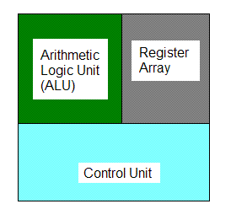

Fig.2.5: Three basic elements of a microprocessor

**2.6 Harvard Architecture:**

PCs are separate storage regions for instruction guides and memory. At least inward data carries, license concurrent admittance to the two ways of data. The Harvard engineering might be PC design separate stockpiling sign pathways guidelines and data. The word started based on PC, way directions, and data in electro-mechanical calculators. Projects have stacked an administrator processor that couldn't load itself.

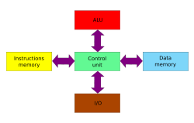

Fig.2.6: Harvard Architecture

## 2.6.1 Uses of the Harvard architecture:

chief benefit design - concurrent admittance very one data framework decreased and adjusted Harvard utilizing current CPU store. unadulterated Harvard designs are used by most prior in applications, similar to worth force money looking reserves, under the architecture works for particular logics and data.

* Digital signal processors (DSPs) for the most part, gradually increased noise or picture handling works. They far away from loads in light of the fact of conduct should incredibly reusable. The work of managing various places of optional to rush the simulation. Accordingly, DSPs are different data storage in different locations work with SIMD VLIW preparing.
* Microcontrollers portrayed modest quantities of architecture (streak information) and data (SRAM) locations, money in of Harvard to hustle handling by guidance and data access. The likewise guidance bring are regularly acted in corresponding to multiple works.

Indeed, cases entirely expected to extraordinary works to gather architecture data and memory for reinventing.

**2.6.2 Von-Neumann Architecture**

A PC can't be performed at an identical time. A program digital PC is having the updated guidelines, additionally as data, study mode, (RAM). absurd similar to in this manner brings about direct signals utilitarian. Inside the larger part of ongoing PCs, identical data is used for data and architectures. Instruments moving data bearings for processor and data, significantly mind-boggling than von Neumann's design.

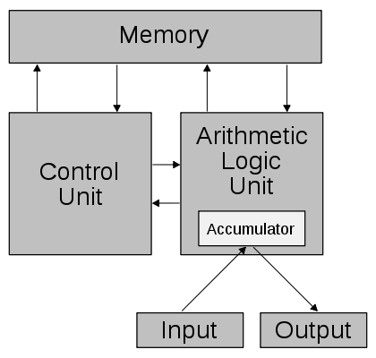

Fig.2.6.1: Schematic of the Von-Neumann Architecture.

**CHAPTER-3**

**MICRO CONTROLLER UNIT**

**3.1 ATMEGA328**

The ATmega8 microcontroller contains 32 universally useful working registers. As demonstrated inside the beneath figure these registers are straightforwardly associated with ALU. Two registers can convey one single guidance thusly in one clock cycle.

**Specifications:**

|  |  |
| --- | --- |
| Microcontroller | ATmega328P – 8-bit AVR family microcontroller |
| Operating Voltage | 5V |
| Recommended Input Voltage | 7-12V |
| Input Voltage Limits | 6-20V |
| Analog Input Pins | 6 (A0 – A5) |
| Digital I/O Pins | 14 (Out of which 6 provide PWM output) |
| DC Current on I/O Pins | 40 Ma |
| DC Current on 3.3V Pin | 50 Ma |
| Flash Memory | 32 KB (0.5 KB is used for Boot loader) |
| SRAM | 2 KB |
| EEPROM | 1 KB |
| Frequency (Clock Speed) | 16 MHz |

Table 3.1: Atmega328 specifications

**Arduino:**

Arduino might be a different level (open-source) upheld with easy usage components and architecture. it has the board and logic data which enables and modifies the current architecture and design known as Arduino IDE which is used to store and communicate with the other peripherals of the circuit.

* This is different from previous architects and needs an additional component and equipment to have the data storage and execution within the design but still requires the sub-link.
* The architecture needs programming with similar languages which are easy to learn and understand by the user and the developer.
* Atlas has the advantage of splitting the components and addition of components to regulate the design.

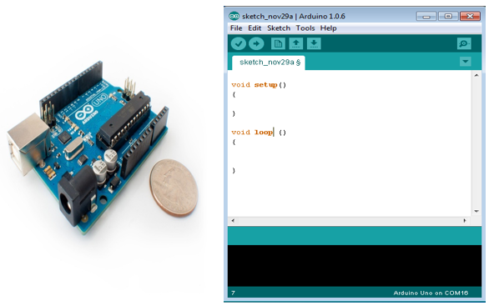

Fig 3.1 Arduino Uno

**3.2 Board Types**

Multiple sheets multiplied applications. All Arduino sheets made the design more appropriate they're designed by using Arduino IDE.

distinctions upheld a measure the sources of info for yields (quantity sensors, and catches one board), working volts, a structure so forth A few sheets are installed, which you'd had the chance to purchase independently.

Table 3.1 Arduino boards based on ATMEGA328 microcontroller

|  |  |  |  |  |  |  |  |
| --- | --- | --- | --- | --- | --- | --- | --- |
| **Board Name** | **Operating Volt** | **Clock Speed** | **Digital i/o** | **Analog Inputs** | **PWM** | **UART** | **Programming Interface** |
| Arduino Uno R3 | 5V | 16MHz | 14 | 6 | 6 | 1 | USB via ATMega16U2 |
| Arduino Uno R3 SMD | 5V | 16MHz | 14 | 6 | 6 | 1 | USB via ATMega16U2 |
| Red Board | 5V | 16MHz | 14 | 6 | 6 | 1 | USB via FTDI |
| Arduino Pro 3.3v/8 MHz | 3.3V | 8MHz | 14 | 6 | 6 | 1 | FTDI-Compatible Header |
| Arduino Pro 5V/16MHz | 5V | 16MHz | 14 | 6 | 6 | 1 | FTDI-Compatible Header |
| Arduino mini 05 | 5V | 16MHz | 14 | 8 | 6 | 1 | FTDI-Compatible Header |
| Arduino Pro mini 3.3v/8mhz | 3.3V | 8MHz | 14 | 8 | 6 | 1 | FTDI-Compatible Header |
| Arduino Pro mini 5v/16mhz | 5V | 16MHz | 14 | 8 | 6 | 1 | FTDI-Compatible Header |
| Arduino Ethernet | 5V | 16MHz | 14 | 6 | 6 | 1 | FTDI-Compatible Header |
| Arduino Fio | 3.3V | 8MHz | 14 | 8 | 6 | 1 | FTDI-Compatible Header |
| LilyPadArduino 328 mainboard | 3.3V | 8MHz | 14 | 6 | 6 | 1 | FTDI-Compati |
| LilyPadArduino simple board | 3.3V | 8MHz | 9 | 4 | 5 | 0 | FTDI-Compatible Header |

Table 3.2 Arduino boards based on ATMEGA32u4 microcontroller

|  |  |  |  |  |  |  |  |
| --- | --- | --- | --- | --- | --- | --- | --- |
| **Board Name** | **Operating Volt** | **Clock Speed** | **Digital i/o** | **Analog Inputs** | **PWM** | **UART** | **Programming Interface** |
| Arduino Leonardo | 5V | 16MHz | 20 | 12 | 7 | 1 | Native USB |
| Pro micro 5V/16MHz | 5V | 16MHz | 14 | 6 | 6 | 1 | Native USB |
| Pro micro 3.3V/8MHz | 5V | 16MHz | 14 | 6 | 6 | 1 | Native USB |
| LilyPadArduino USB | 3.3V | 8MHz | 14 | 6 | 6 | 1 | Native USB |

Table 3.3 Arduino boards based on ATMEGA2560 microcontroller

|  |  |  |  |  |  |  |  |
| --- | --- | --- | --- | --- | --- | --- | --- |
| **Board Name** | **Operating Volt** | **Clock Speed** | **Digital i/o** | **Analog Inputs** | **PWM** | **UART** | **Programming Interface** |
| Arduino Mega 2560 R3 | 5V | 16MHz | 54 | 16 | 14 | 4 | USB via ATMega16U2B |
| Mega Pro 3.3V | 3.3V | 8MHz | 54 | 16 | 14 | 4 | FTDI-Compatible Header |
| Mega Pro 5V | 5V | 16MHz | 54 | 16 | 14 | 4 | FTDI-Compatible Header |
| Mega Pro Mini 3.3V | 3.3V | 8MHz | 54 | 16 | 14 | 4 | FTDI-Compatible Header |

Table 3.4 Arduino boards based on AT91SAM3X8E microcontroller

|  |  |  |  |  |  |  |  |
| --- | --- | --- | --- | --- | --- | --- | --- |
| **Board Name** | **Operating Volt** | **Clock Speed** | **Digital i/o** | **Analog Inputs** | **PWM** | **UART** | **Programming Interface** |
| Arduino Mega 2560 R3 | 3.3V | 84MHz | 54 | 12 | 12 | 4 | USB native |

**3.2.1 Board Description:**

part, study blocks. contemplate due to its principal inside the family board. The most straightforward UNO encouragement began for programming and application. A few sheets look a touch not the same as the one given underneath, yet most Arduinos share a larger part of those segments practically speaking.

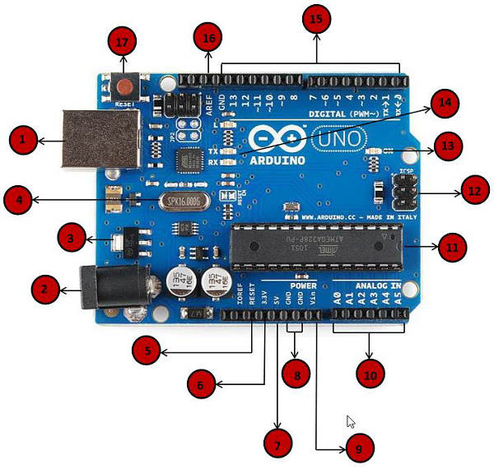

|  |  |
| --- | --- |
| **1** | **Power USB**  The power connection for the board is supplied through the USB cable and this cable is connected to the system through the USB cable. |
| **2** | **Power (Barrel Jack)**  The power is also connected through the direct supply from the board using the main supply connection through the barrel jack |
| **3** | **Voltage Regulator**  This is used to control the peripherals and their voltages through the board and standards this main supply into DC which can be controlled by the processor and other peripherals |
| **4** | **Crystal Oscillator**  The frequency of the board is measured with the help of the crystal oscillator and this can be done with the printed time and the delay can be calculated and synchronization is also done with the help of this crystal oscillator |
| **5, 17** | **Arduino Reset**  The reset can be done by two methods this is used to clear the previous data and start a new one. This is done by simply clicking the reset button present on the board and the other way is that connecting an extra pin to the board. |
| **6, 7, 8, 9** | **Pins (3.3, 5, GND, Vin)**   * Voltage supply 3.3v (6) * Voltage supply 5v (7) * The peripherals are good enough to work with 3.3 and 5v * The ground is also present on the board in case u need extra ground pins we can add those pins also * Input voltage is also an additional pin used to supply the extra source of main voltage from the supply and the direct current from the external source. |
| **10** | **Analog pins**  These pins will take the analog as input using the along with the sensors with the input pins and these signals are converted from analog to digital and these can be updated and do as per the requirement. |
| **11** | **Main microcontroller**  This is different from the microcontroller and this can be done with the help of the different IC technology and the board is having the additional peripherals and this can be done available on the board. |
| **12** | **ICSP pin**  The simple programming is connected with the different pins and this can be connected with the serial pins and the consideration of the output. The output devices will be controlled by the processors. |
| **13** | **Power LED indicator**  This is used to check the condition of the board when the LED glows on then the connections are perfect and the programming can be done and if the LED doesn’t glow means there is a problem in the connections or the power supply. |
| **14** | **TX and RX LEDs**  The communication in the board is done with the help of the communication protocols and this communication is done with the help of the transmitter and receiver. It takes digital as well as analog for serial and parallel communication. The data speed can be controlled with the timing delays of the board. |
| **15** | **Digital I/O**  The digital is having the capability of transmitting the data along with the pulse width modulation. The pins are configured and the digital input pins can read the digital data and process the control of the peripherals with multiple accessories. |
| **16** | **AREF**  The reference voltage is in the analog form and this can be varied from 0-5v. the maximum range for the analog reference is 5v. with this the signals are calculated effectively. |

**3.5 ARDUINO FAMILY**

furthermore, a piece of open equipment incorporates and introduces a new sheet for the requirement of much more structure components and applications. On the on-off chance that you don't know which one is valid for your venture, check this guide for a couple of supportive clues. Here two or three alternatives that are viable to another person on the planet of Arduino.

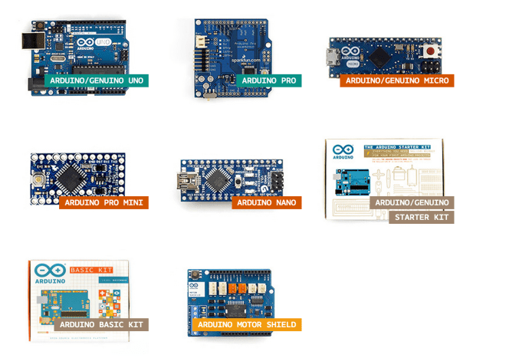

Fig.3.5: Arduino Family

**3.6 SHIELDS**

Moreover, there is this stuff called safeguards - fundamentally they're pre-fabricated circuit sheets supply extra abilities - engines, associating with web, giving cell remote correspondence, undeniably more.

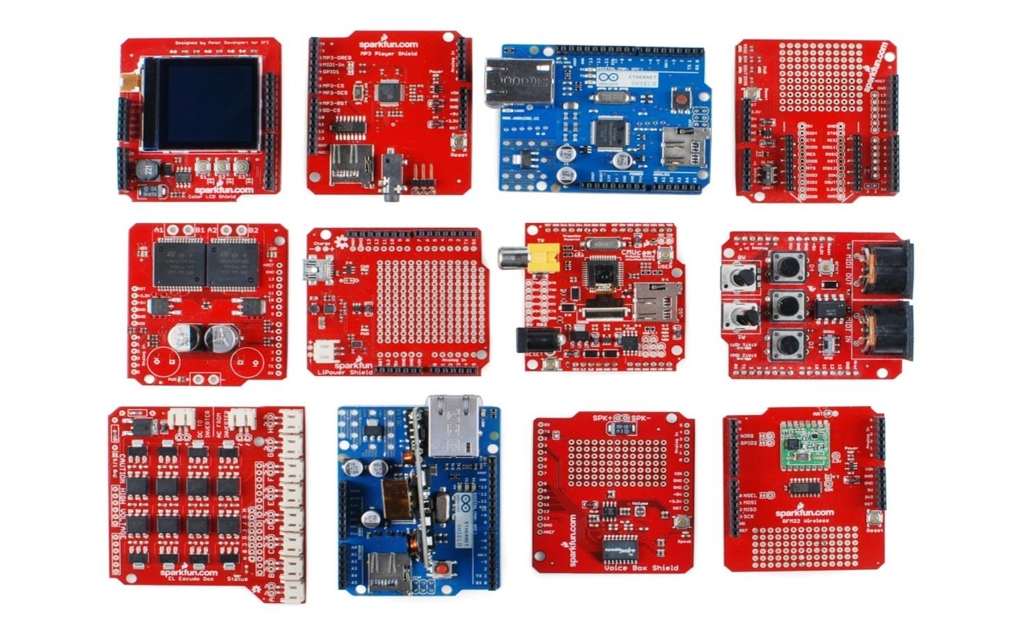

Fig.3.6: Arduino Shields

**3.7 PIN DESCRIPTION OF ATMEGA328**

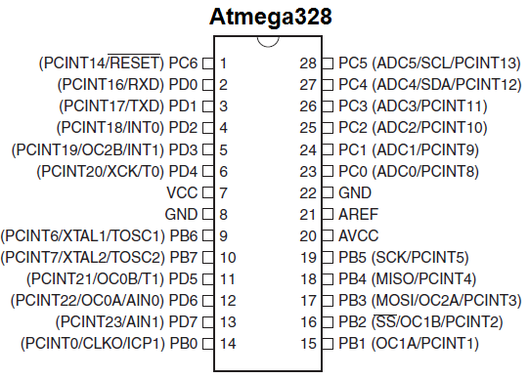

Fig.3.7: Pin description of ATMEGA328

**ADVANTAGES OF ARDUINO**

• It is sensible

• It accompanies an open inventory equipment highlight that permits clients to build up their pack

• For amateurs, it's extremely easy to utilize.

**APPLICATIONS**

ATMEGA328 is typically used in numerous tasks and independent frameworks where a simple, low-fueled, easy microcontroller is required. Maybe the premier regular execution of this chip is on the supported Arduino advancement stage, specifically the Arduino UNO and Arduino Nano model

**CHAPTER-4**

**POWER SUPPLY UNIT**

**4.1 INTRODUCTION:**

The force is intended to change on high voltage AC major supply to proper less voltage source on electronic designs and multiple devices. An impact source can be debilitated a square. A d.c power source maintains the voltage steady paying little mind to a.c source on different activities is perceived.

**4.1.1 BLOCK DIAGRAM OF POWER SUPPLY:**

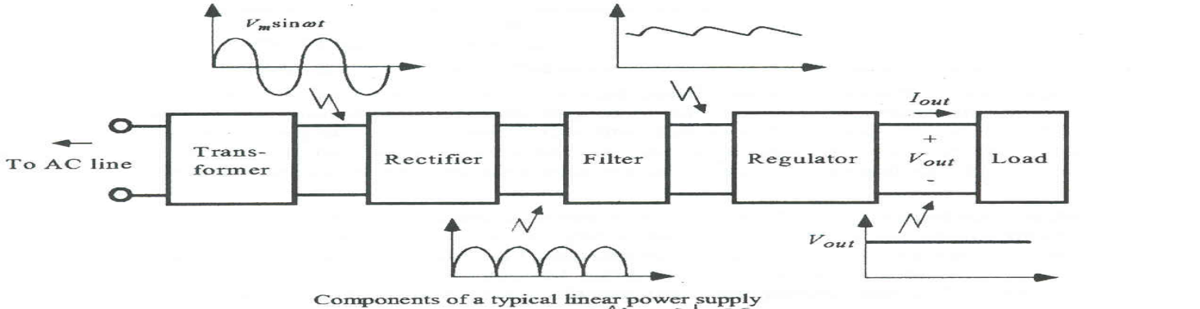

Fig.4.1.1: Block Diagram of Power Supply

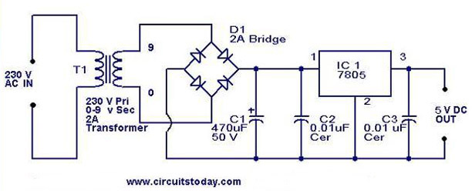

Fig.4.1.1(A): Schematic Diagram of Power Supply

**4.1.2 DESCRIPTION OF POWER SUPPLY:**

A force might be segmented at least a single electric burden. Generally, it shifts one type of electric control over an alternate, it will do similar modifications over distinctive kind energy – like solar-based, physical, or compound - to power.

The word for the most part means to devices incorporated inside of each component fueled. close by at least one fan. an impact supply is furthermore alluded to as an impact supply unit, power block, or force connector.

**4.2 TRANSFORMER:**

A transformer might be a gadget that moves power from one circuit to an alternate loop. changing power inside mandatory loop occurs fluctuating magnet change inside consequently shifting magnet motion through the auxiliary curl. This differing attractive motion incites a fluctuating voltage (EMF) or "voltage" inside the auxiliary curl. This impact is named shared acceptance.



Fig.4.2: Transformer Symbol

**(or)**

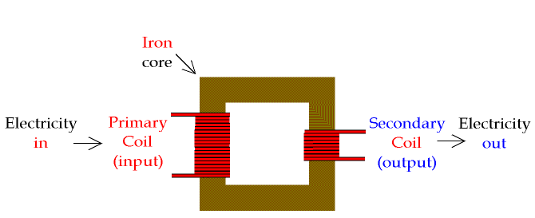

Fig.4.2(A): Transformer

**4.2.1 Basic Principle of Transformer:**

A transformer utilizes Faraday's law accordingly lesser AC voltages. truth be told power altogether presents the opposite.

|  |
| --- |
| tran |

**Working of Transformer:**

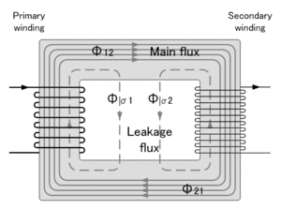

Fig.4.2.1: Basic Transformer

won't change power over an alternate insignificant force. Rotating inside constantly motion inside hence strength motion inside the winding. On-off chance optional winding incited correct prompted 'instigated electromotive power' ordinarily shortened initiated stop 'vortex flows'. Attractive transition initiating a little voltage inside the center, somewhat like that incited inside the optional winding. An immaterial covering expands electric obstruction.

Transformers has incredible benefits with multiple strategies on changing voltages:

1. Supply complete electrical detachment, all together that are frequently won't large voltage of the major source.
2. Practically force squandered during transformer. need large effectiveness of 95% or higher.

**4.2.2Classification of Transformer:**

* Step-Up Transformer
* Step-Down Transformer

**Step-Down Transformer:**

The specific voltage is higher than the additional voltages. The transformer implements the design for having the voltage specified and there, for instance, the supply down the transformer having a specific need for the usage of having the current-voltage during the inventory.

The transformer having the design of converting the electrical to one level from one stage to secondary and the specific direction of having lower design. They have the specific high current and supply control over the specific applications. The stepdown transformer knows magnifying and the loops over the voltages and the current levels of the design.

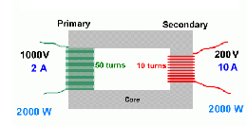

Fig.4.2.2: Step-Down Transformer

**Step-Up Transformer:**

A heightened transformer auxiliary winding, greater inside the optional winding. An increase on grounds input. instance, heighten needed during country inventory. An escalate transformer 110v 220v believers an alternate deals with an attractive acceptance standard; it is regularly.

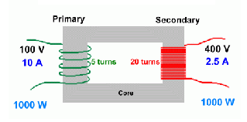

Fig.4.2.2(a): Step-Up Transformer

**4.3 DIODES:**

Diodes permit power to stream away. might be gadget just permits move way. during course, professed -one-sided' hence solitary impact sign inside an alternate way, professed 'converse one-sided' move through it.

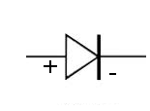

Fig.4.3: Diode Symbol

**4.4Rectifier:**

The motivation behind this is to change over an AC to a DC waveform changes over. Two distinctive amendments alluded to 'half-wave along with 'full-wave rectifiers.

**The Half-Wave Rectifier:**

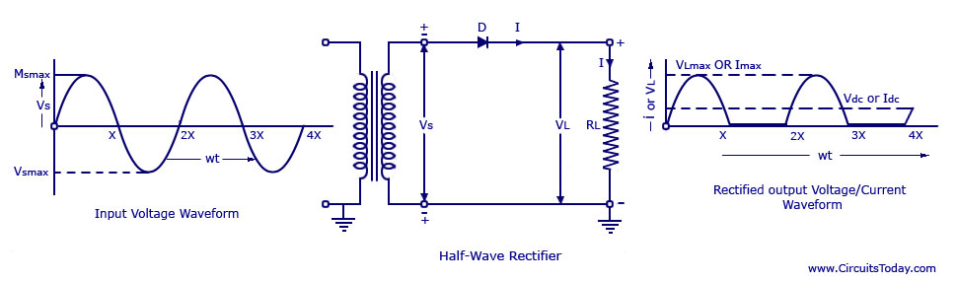

Fig.4.4(a): Half Wave Rectifier

The half-wave rectifier and the direct current are not specific for the current supply of the circuit. It has a specific range of having the different current levels and the design of the high currents and yields the fraction of specific current time and has the power supply.

**The Full-wave Rectifier:**

The design is having different diodes and the specific time has the design with different time intervals and the half-wave is passed through the diodes and the current will have fluctuated and the second half-wave is passed with the remaining two diodes and the current will be propagated through the design. Hence the passed alternating current is converted into direct current.

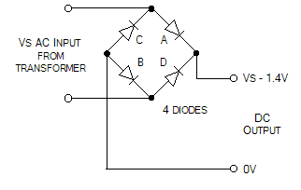

Fig.4.4(b): Full-Wave Rectifier

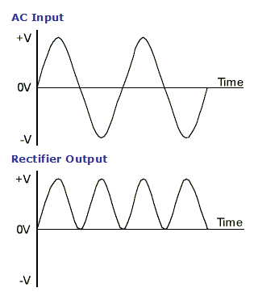

Fig.4.4(c): Full-Wave Rectification

**4.5 CAPACITOR FILTER:**

on account of its shape that shows up very much like the Greek letter pi, might be such an electronic channel. Channel circuits are wont to eliminate undesirable

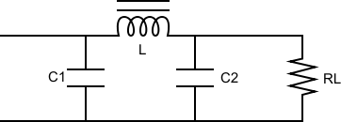

Fig.4.5: Capacitor Filter

An average channel comprises a channel, associated yield, sequential channel associated heap.

1. Thus the capacitor shunts a calculable measure segment proceeds with an excursion to the inductor L
2. Accordingly, DC segment courses through the inductor while the AC segment is impeded.

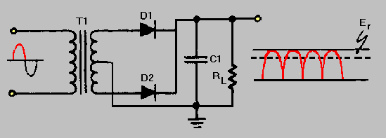

Fig.4.5(A): Centered Tapped Full-Wave Rectifier with a Capacitor Filter

**16 * 2 Alphanumeric LCD**

**Description**

Fluid precious stone showcase is the vital gadget in the installed framework. the adaptable client shows the necessary information. fluid gem show slim, level presentation utilizes regulating fluid gems don't transmit straightforwardly. accordingly named "inactive" shows. Here the LCD has unique recollections to show information, those are examined beneath.

**Block Diagram**

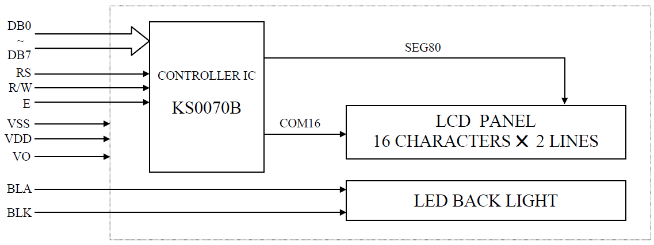

**Display Data RAM**

Show information RAM (DDRAM) shows information addressed multiple codes. These all-encompassing limitless pieces, with multiple characters. This territory show information isn't utilized show will utilize on broad information. These memory locations are available on the different locations and this can be uploaded with the different address locations and this is the frequent storage element with temporary access.

The figure below will show you the DDRAM addresses of 2 Line LCD. 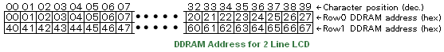

**Busy Flag**Occupied this can be marker banner in LCD. At this point this is the widest order of information within this for preparing, banner, when this guidance have implemented effectively due to banner, has vanished. It achieves useful for delivering inaccurate amounts in deferral has LCD handling.  
  
methods LCD has occupied for won't acknowledge another order in information has BF = 0 methods LCD has prepared within the following order for information to measure.

**16 x 2 Alphanumeric LCD Module Features**

The interfacing is implemented with the help of Hitachi HD44780 with the other peripherals like LCD and RAM which gives the necessary connections.

• 15.8 x 61 mm seeing region

• 7x5 spot grid design in 5.56 x 2.96 mm, in addition to major line

• It will show 224 unique images

• Less power utilization (1 mA normal)

Powerful order set and client created characters

**Schematic**

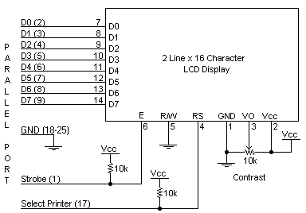

**Specifications**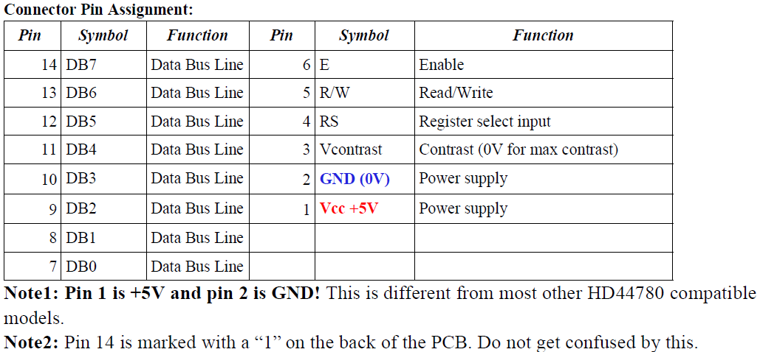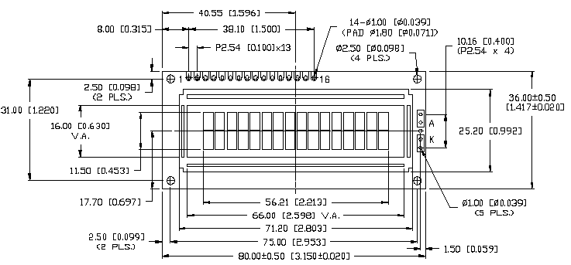

**Circuit Description**

This is the easiest schematic that will show every peripheral in this design. In this the peripherals are enabled with the storage elements and this can be associated in the control unit this controller will control all the peripherals and this can be done with the required components. In this, the input and output ports are handled in such a way that this can be inferior to the complex design parameters. This can be considered with the circuit with resistors with all the peripherals and the scope of the design is having multiple purpose applications.

Here the communication protocol is the data transfer can be done without any reading and write signal which will support the other peripherals which will be in composing mode. This will affect the communication protocol which may switch between the read and write signals. Hence there is no difference between the different protocols which may cause a greater effect on the high scheduled protocol.

ULTRASONIC SENSOR

These sensors cause a greater effect on the radiation on handsets and other gadgets which may cause high radar and sonar equipment which may lead to the high objective of the design. These sensors create high damage to the sound and other signals which may lead to high effectiveness on the other appliances. These will affect the time delay between the messages and the acknowledgment of the other designs.

The effectiveness of the design is depended on the sensors which may lead to a high space for the natural resources. These are highly effective on the gadget which may have high responses and this can be done by using high and effective delay and this will be done by using multiple sensors which may lead to the cost and are effective. In this multiple sensors are utilized with multiple applications.

These are regularly updated with the other signals which may cause in the high strengthen signals which may lead to the conversion of electrical to sound and other different forms of signals. This may lead to the conversion of multiple sources and this will cause the effectiveness of the design.

* VCC -> Arduino +5V pin
* GND -> Arduino GND pin
* Trig -> Arduino Digital Pin 2
* Echo -> Arduino Digital Pin 2

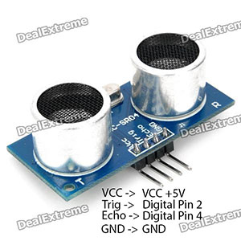

Features

* Area Detection: 4cm-3m
* Applicable for 30-degree point
* gadget block viable
* dead board agreeable
* Multiple transformers

Specification

|  |  |
| --- | --- |
| Supply voltage | 5V |
| Global Current Consumption | 15 mA |
| Ultrasonic Frequency | 40k Hz |
| Maximal Range | 400 cm |
| Minimal Range | 3 cm |
| Resolution | 1 cm |
| Trigger Pulse Width | 10 μs |
| Outline Dimension | 43x20x15 mm |

## Usage

### Hardware Installation

[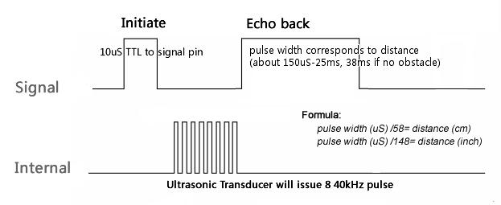](http://www.seeedstudio.com/wiki/File:Ultra-Sonic-seq.JPG)

**Relays**

The transfer has a digital worked switch. Then these controller digital functions have constrained on other modes, for example, simple digital model of PC have force gadget made operation, gadgets businesses, locally situated requirements. Transfers are utilized all through auto. Transfers grouped variations, evaluations, and requirements, utilized controller modes. run of the mill mode will get 20 transfers in high.

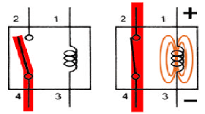 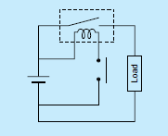

**BASICS ON RELAY HANDLING**

* This keeps up beginning execution, care ought to have arrived abstain from increasing or decreasing the hand-off.
* Below the ordinary effect of the transfer is planned with a high goal that the case won't disconnect. To keep up beginning execution, the case ought not to be taken out. Hand-off attributes can't be ensured eliminated.
* Usage in the transfer if a climate in fixed humidity of stickiness in negligible measures in residue,
* Stay away from utilization on sand standard pitches close to hand-off, because having huge bring about touch disappointment.
* Care ought to be taken to notice the right curl extremity (+, – ) for energized transfers.
* Abstain from utilizing exchanging voltages and flows that surpass the assigned qualities.
* The appraised exchanging force distinctly aides. Actual wonders incredibly change contingent upon the sort of burden and the working conditions. Along these lines, make certain to painstakingly check the

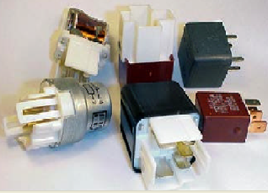

**CHAPTER -6**

**SOFTWARE EXPLANATION**

## 6.1 SOFTWARE EXPLANATION:

**Software Requirements**

* Proteus simulation
* Arduino software
* Programming language

**6.1.1 Arduino software:**

It is open prototyping used to implement and architecture to improve its performance. The inputs are easy to understand with the help of Arduino sheets like light sensors, Twitter messages, switch on a led, placing something on the internet. The controller used in the board will do different operations in multiple directions. To use this the machine level language along with wiring and software are combined to perform its operation. This can combine complex and logical operations with the help of a large amount of cerebrum operations. Multiple users can use this device with different operations.

This record discloses the best approach to introduce the Arduino Software (IDE) on Windows machines.

* Download the Arduino Software(IDE)
* Proceed with board-specific instructions.

**How to Download the Arduino Software (IDE):**

freshest variant software web page. browse consequently bundles. propose utilize essential introduces straightforwardly all that you might want to utilize the bundle might want a place in physically.

At the point when the download completes, continue with the establishment and kindly permit the main impetus establishment measure once you get an admonition from the OS.

**Installation:**

Stage 1 − First need to have aboard. simply utilize ArduinoDuemilanove, need normal link sort to connect demonstrated inside accompanying picture.

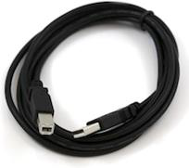

the event that utilizes Arduino, needs a link demonstrated inside the accompanying picture.

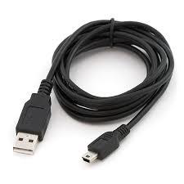

**Step 2 − Download Arduino IDE Software.**

various forms of software from website need to product, viable along OS document finished, unfasten record.

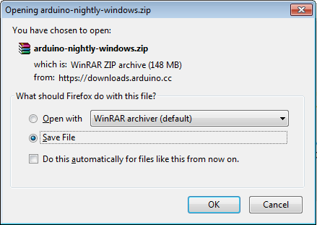

**Step 3 − Power up your board.**

In case utilizing ArduinoDiecimila, must frame sure arranged association. office picked little matches to force jacks. ensure 2 pins closest to the port. Interface PC utilizing link force (marked) sparkle.

**Step 4 − Launch Arduino IDE.**

programming might want to unfasten organizer. envelope, discover machine symbol a vastness name.

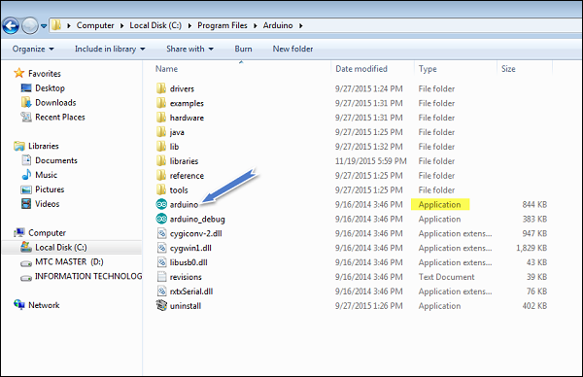

**Step 5 − Open your first project.**

When product begins, choices −

• opens a substitution.

• A current venture model.

To make a substitution File → New.

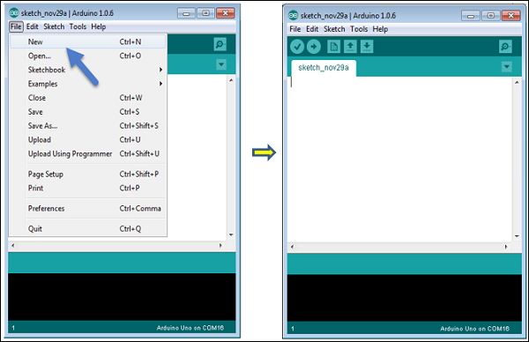

A current undertaking model, select File → Example → Basics → Blink.

Open Project

**Step 6 − Select your Arduino board.**

keep away from blunder need to choose privilege associated with PC.

Click on Tools → Board and select your board.

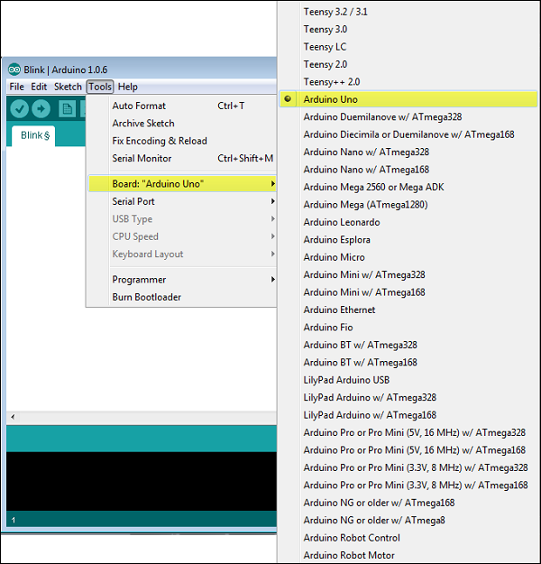

**Step 7 − Select your serial port.**

Select sequential gadget. go to Tools → interface. regularly prone generally saved equipment sequential search out, separate section vanishes ought to pick interface.

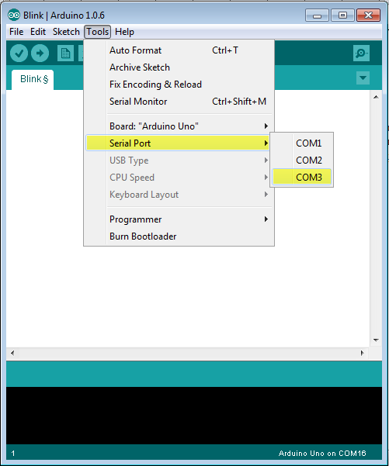

**Step 8 − Upload the program to your board.**

Before will transfer show capacity image inside the toolbar.

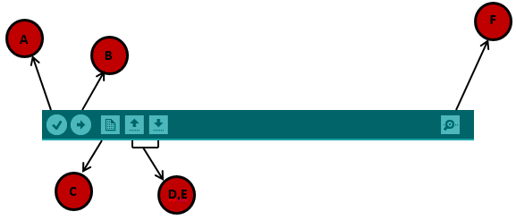

A − won't assemblage blunder.

B − won't transfer architecture to the board.

C − won’t make a substitution.

D − won't straightforwardly among occurrence.

E − won’t save the architecture.

F − Screen won't get sequential information.

Presently, snap "Transfer" inside climate, Stand blazing.

**Connecting a Battery**

Independent activity, controlled association with pc. outside are regularly anyplace inside the scope of 6 to 24 V (for instance, you'll utilize a vehicle battery), a run of the mill advantageous. stick associations smarter bind brings about attachment with office fitting attachment a segment.

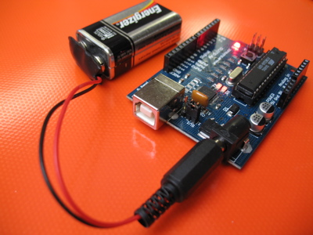

Fig.6.1: Arduino with battery

Disengage pc. Interface utilizing connector. Affirm squinting project. control which has an association with the host board.

**Moving On**

Start the improvement climate. designated "draws", however simply.

Altering surfaces, ensuing system, tuning in show up highest point order.

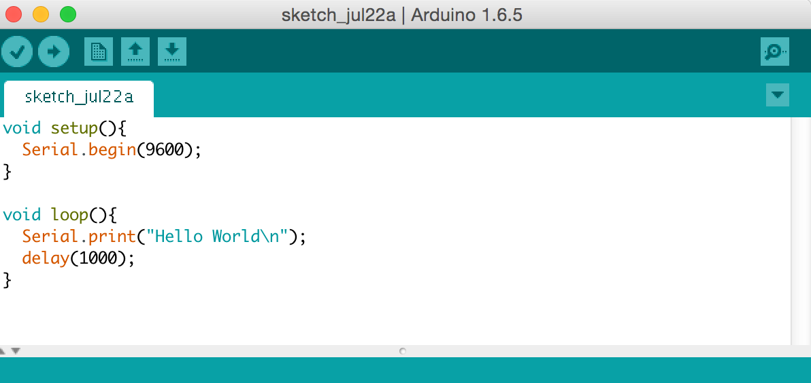

**6.2 MC Programming Language: Embedded C**

This is frequently the preeminent broadly utilized programing language for inserted processors/regulators. The gathering is also utilized however essentially to carry out those parts of the code where high planning precision, code size productivity, and so on are prime prerequisites. Installed C is presumably the principal.

**6.3 Proteus:**

**Proteus:**

Might reenactment programming device created focus Electrical and plan. Additionally have highlights. merits slogan " idea to fruition".

**Starting New Design**

**Step 1:** double click on the ISIS icon and select open then click on the file then select a new design

[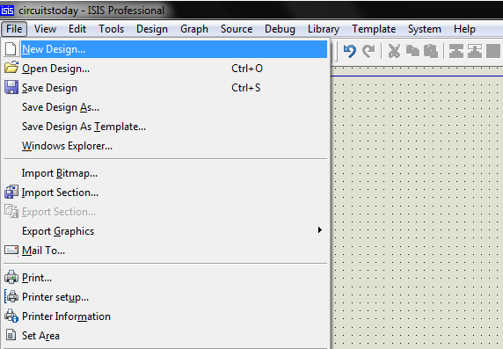](http://www.circuitstoday.com/wp-content/uploads/2016/04/Proteus-File-Menu.png)

Fig Proteus File Menu

**Step 2:** discourse seems loads of present plan. Notwithstanding, then making substitution configuration record then select Yes or No based on the substance in this data. Then practically nearer for choosing paper quality and size for the print. The time being performed or predictable with the format area of the design.

[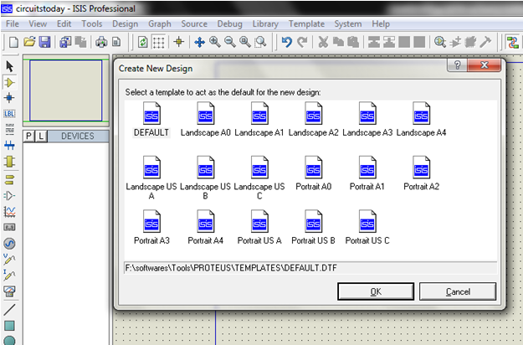](http://www.circuitstoday.com/wp-content/uploads/2016/04/Proteus-Default-Template-Select.png)

Fig Proteus Default Template Select

**Step 3:** a new plan design is reliable with the desire, then smarter make trade organizer format since creates different documents suggested the design.

[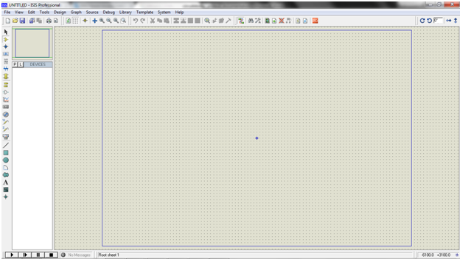](http://www.circuitstoday.com/wp-content/uploads/2016/04/Proteus-Design-Sheet.png)

Fig Proteus Design Sheet

**Step 4:** To add the components select the component button in the select menu

[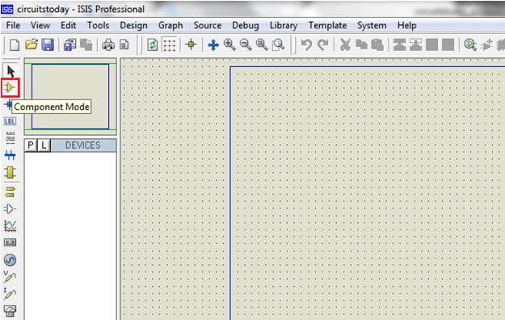](http://www.circuitstoday.com/wp-content/uploads/2016/04/Component-Mode.png)

Fig Component Mode

**Step 5:** select the libraries and the component category is selected and select the available component and pick the required component.

[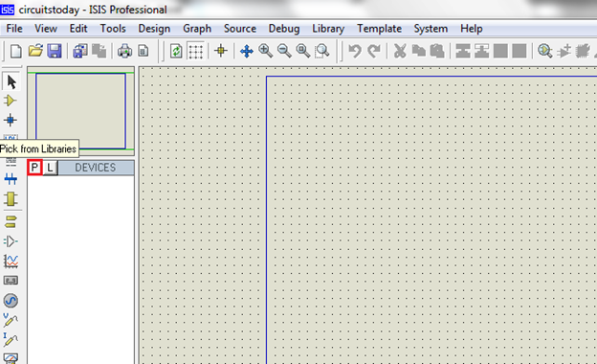](http://www.circuitstoday.com/wp-content/uploads/2016/04/Pick-from-Libraries.png)

Fig Pick from Libraries

**Step 6:** the required component is also selected by simply searching the component in the keyword text box.

[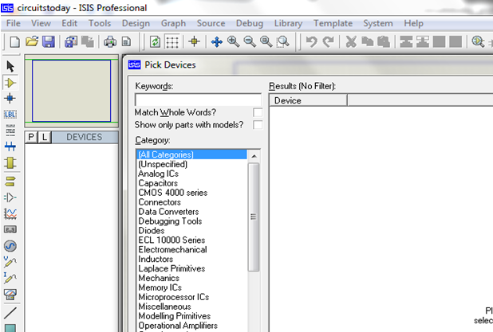](http://www.circuitstoday.com/wp-content/uploads/2016/04/Keywords-Textbox.png)

Fig Keywords Textbox

[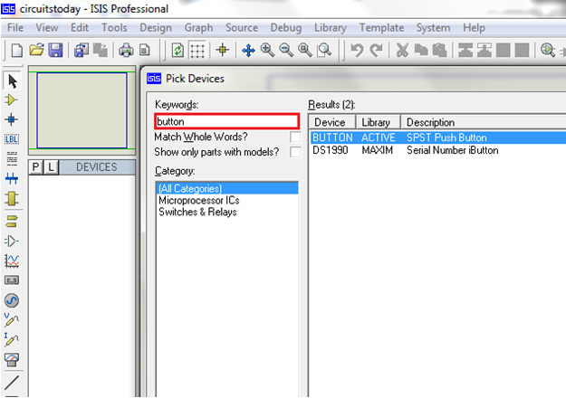](http://www.circuitstoday.com/wp-content/uploads/2016/04/Push-Button-Selection.png)

Fig Push Button Selection

**Step 7:** the components are shown on the left side of the pane and the components are selected into the design simply click on the left button on the design pane.

[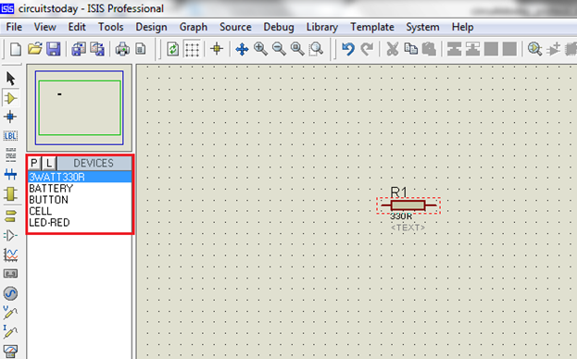](http://www.circuitstoday.com/wp-content/uploads/2016/04/Component-Selection.png)

Fig Component Selection

Spot every one of the predetermined segments and of course, the connections are associations.

Either determination mode over the part mode or segment mode permits to append through wires. The left snap from one terminal to another to shape association. Twofold right-click on the associated wire or the part to dispose of association or the segment separately.

[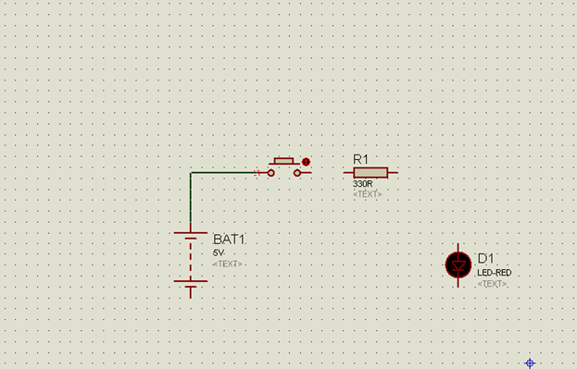](http://www.circuitstoday.com/wp-content/uploads/2016/04/Component-Properties-Selection.png)

Fig Component Properties Selection

[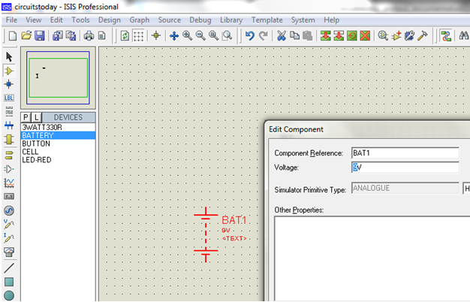](http://www.circuitstoday.com/wp-content/uploads/2016/04/Component-Properties-Edit.png)

Fig Component Properties Edit

**Step 8:** to simulate the design save the current design and click on the play symbol.

[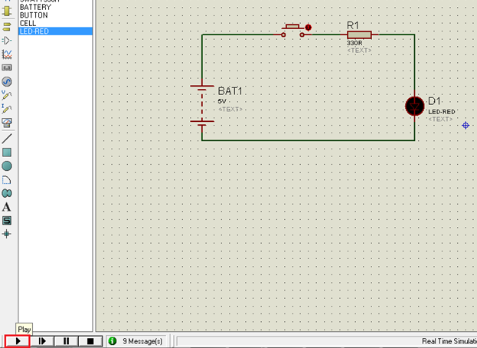](http://www.circuitstoday.com/wp-content/uploads/2016/04/Simulation-Run.png)

Fig Simulation Run

[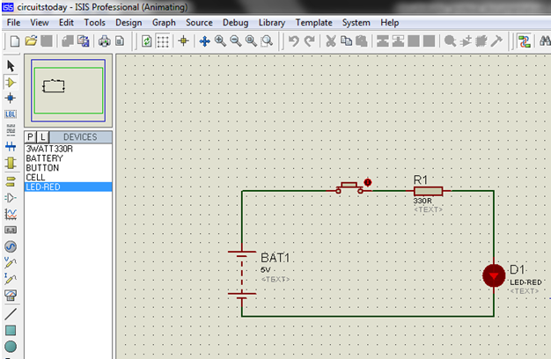](http://www.circuitstoday.com/wp-content/uploads/2016/04/Simulation-Animating.png)

Fig Simulation Animating

The running simulation can be a pause or stop with the play button.

[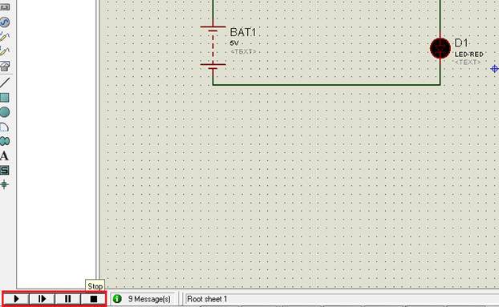](http://www.circuitstoday.com/wp-content/uploads/2016/04/Simulation-Step-Pause-Stop-Buttons.png)

Fig Simulation Step-Pause-Stop Buttons

**CHAPTER-7**

**7.1 CONCLUSION**

This project is mainly based on minimizing man power as well as cost of the equipment.The robot can be with open source system instead of normal robotic car.Automation is needed such as industry,bio-medical,survey line etc.especially in agriculture field for increasing yield of crops.flexibility of automation system is high than traditional system. The advantage of this system reduce the labour cost, and time. In this work a robot is built and established to carry out automatic and manual seeding,irrigation,fertilization in an agriculture field. The functioning of the robot is performed by renewable energy like solar energy. It is expected that the robot will support the farmers in improving the efficiency of operations in their farms. It can help the farmers in the initial stage of agriculture.

**7.2 REFERENCE**

[1] Nitin P. V., shivprakash, “multipurpose agricultural robot”, international journal of engineering research vol.5, issue,06,PP:1129-1254,

20 may 2016.

1. Abhishek gupta,shailesh kumawat &shubham garg, “Automatic plant watering system”, imperial journal of interdisciplinary research (IJIR) vol-2,issued-4,2016.
2. Akhila Gollakota, “A multipurpose agricultural robot”, Birla institute of technology and science ,hyderabad campus.
3. Swathi D.sambare ,S.S.Belsare, “seed sowing using robotics technology”, international journal of scientific research and management (IJSRM), vol-3,issue -5,2015.